**AOP Ordering Aspects - Overview**

**Problem**:

How to control the order of advices being applied?

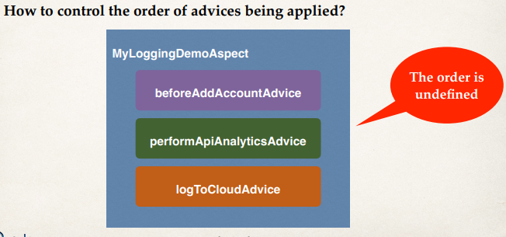

**To Control Order**:

1. Refactor: Place advices in separate Aspects
2. Control order on Aspects using the @Order annotation
3. Guarantees order of when Aspects are applied

**Development Process (Step-by-Step)**:

1. Refactor: Place advices in separate Aspects
2. Add @Order annotation to Aspects

**Step 1 - Refactor: Place advices in separate Aspects**:

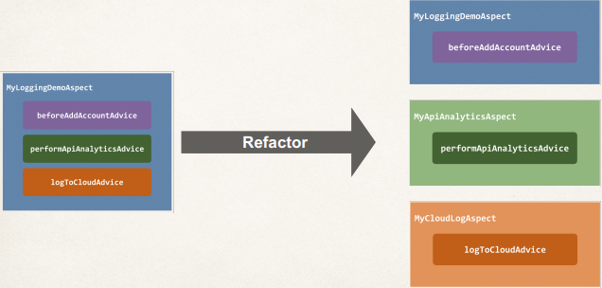

**Step 2 - Add @Order annotation**:

1. Control order on Aspects using the @Order annotation

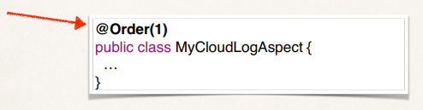

1. Guarantees order of when Aspects are applied
2. Lower numbers have higher precedence

**Order**:

We want the following order

1. MyCloudLogAspect
2. MyLoggingDemoAspect
3. MyApiAnalyticsAspect

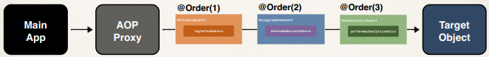

**@Order annotation**:

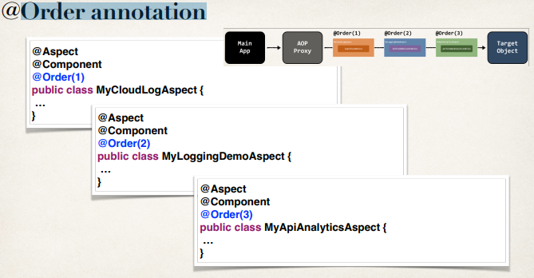

1. Lower numbers have higher precedence
2. Range: Integer.MIN_VALUE to Integer.MAX_VALUE
3. Negative numbers are allowed
4. Does not have to be consecutive

**Does not have to be consecutive**:

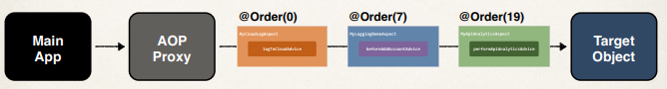

**Order example with negative numbers**:

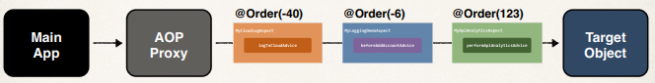

1. AOP Ordering Aspects - Overview